
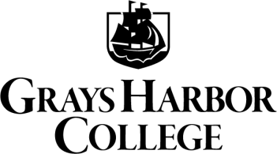
Reasonable Accommodations

Appeals
ACCESSIBILITY SERVICES (AS)

When initiating the appeal process, students will make a good faith effort, with direct intervention from the Accessibility Services Coordinator in the Accessibility Services (AS) Office, to collaborate with the individual faculty or staff, division chair, dean’s offices, and/or committees involved to try and resolve accommodation concerns. After exhausting all attempts to resolve issues through different pathways, and if the student believes that their accommodation concerns are still not being met, then the student may utilize the following appeal process:

If a student believes that the AS Coordinator has not provided reasonable and appropriate accommodations, or if the student believes that some individual, office, or group has failed to appropriately accommodate their needs, then the student has a right to appeal.

- The student shall submit a written appeal to the Dean of Student Services and Enrollment Management outlining the factual basis and rationale of the appeal.

- Within fifteen (15) instructional days, the Dean of Student Services and Enrollment Management, the Dean of Arts, Sciences, and Extended Learning and/or Dean of Workforce Education will review the appeal and make recommendations in writing for appropriate resolution.

- If a satisfactory resolution is not reached, the student may present their appeal to the Vice President of Student Services.

- The Vice President for Student Services shall respond in writing within fifteen (15) instructional days of the receipt of the appeal. The decision of the Vice President for Student Services is the final decision of the institution.

If a student has a grievance and would like to seek resolution outside the College, the student should contact:

Seattle Office  Office of Civil Rights  U.S. Department of Education  915 Second Avenue, Room 3310  Seattle, WA 98174-109  Phone: 206-607-1600  TDD: 206-607-1647  Fax: 206-607-1601  E-mail: OCR.Seattle@ed.gov | WA State Human Rights Commission  Olympia Headquarters Office  711 S. Capitol Way, Suite 402  Olympia, WA 98504-2490  Phone: 360-753-6770  Toll Free: 1-800-233-3247  TTY: 1-800-300-7525  Fax: 360-586-2282

