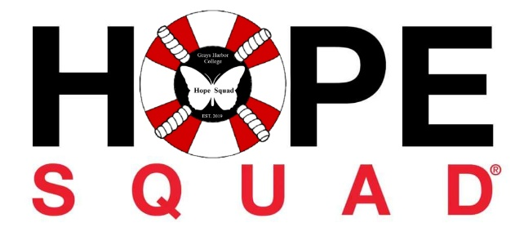

**Grays Harbor College Hope Squad Meeting Minutes**

**Friday, August 30th 2024**

1. **Call to order**

Cari called to order at 6:15 PM

1. **Roll call**

President: Cari, Present

Vice President: Laura, Present

Treasure/Rep: Scye, Present

Secretary: Joy, Present

Public Relations: Nancy, Present

**Statements of the gallery:**

No statements

1. **Approval for Agenda :**

Motions to approve agenda-

Nancy motioned Scyeland seconds the motion, Vote passed 5-0-0

**Approval of Minutes:**

No previous minutes to approve

**Officers Reports:**

Discussion; Loggers playday parade, training, team building

Pick up the for loggers playday packet the night before, this contains our number and where we will be placed in the parade.

We decided to meet at 10:30 am because Loggers Playday Parade starts at 12 pm on Saturday, September 7th 2024 in Hoquiam Washington

Cari, Joy, Scye and Nancy will be walking in the parade, Joy & Nancy will hold the signs. Handing out candy but not too much, maybe a few pieces to each kid, to make sure we don’t run out before the parade ends.

Shelly is bringing the info sheets

Scye will post a picture of the hope squad banner in group chat

Training; After 5 pm, we hope to get training done within the next few weeks.

Pot luck BBQ for team building, everyone will bring their favorite dish

Scye and Laura made their hope squad sweaters, Scye cut out letters for Cari

**Unfinished Business**

No unfinished business

**New Business**

Discussion- Approved Out of the darkness walk shirts for officers, Shelly and an extra in case another person comes; 7 shirts in total. Shirts are $20 dollars each on the hope squad website. $140.00 dollars before taxes and shipping. Asking for $215.00 out of our account fundraising account.

Color- Royal, Cari- Medium, Laura- Large, Scye- Medium, Joy- XL, Nancy- Medium, Shelly- Medium, Extra- Large

**Vote**- Vote passes 5-0-0

Executive Session-No Executive session

Adjournment 6:51 PM